OOP Lab Practical – 4

Name: Divyam Kumar

SAPID: 500083141

Roll No: R214220434

Batch: B2

**Title: Class, Objects, Methods and Constructors**

1. Write a JAVA program to implement class mechanism. – Create a class, define data members, constructor, methods (setData(args),getData()) and invoke them inside main method.

2. Write a JAVA program to implement compile time polymorphism.

3. Write a JAVA program to implement type promotion in method overloading.

4. Write a JAVA program to implement constructor overloading

Question 1:

ALGORITHM:

Step 1 : START

Step 2: Create a class Student

Step 3: Initialize rollno as integer variable to store roll number, age as Double variable to store age and s as String variable to store name

Step 4: define method setData as void with arguments to accept roll number, marks and name

Step 5: Assign values to roll, marks and name as the statements of setData method

Step 6: Define method getData as void with no arguments

Step 7: Display roll number, marks and name as statements of getData method

Step 8: Define main function

Step 9: Create s1 as instance of class in statement of main function

Step 10: Pass values for setData method in statement of main function

Step 11: Call getData function to fetch the data for instance s1

Step 12 : END

CODE:

import java.util.*;

class Student

{

String s;

int rollno;

double age;

Student()

{

System.out.println("Constructor Created");

}

void setData(String n,int r,double a)

{

rollno = r;

age = a;

s = n;

}

void getData()

{

System.out.println("NAME: "+s);

System.out.println("ROLLNO.: "+rollno);

System.out.println("AGE: "+age);

}

public static void main(String[] args)

{

Student st = new Student();

st.setData("Divyam",12,19);

st.getData();

System.out.println("Divyam Kumar\n500083141");

}

}

OUTPUT:

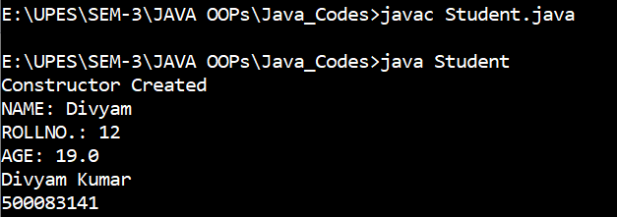

Question 2:

ALGORITHM:

Step 1: START

Step 2: Create class Vehicle

Step 3: define method car accepting 3 arguments of String , integer and double

Step 4: Print the values passed in statement of method

Step 5: define method car again accepting 2 arguments of String.double

Step 6: Print the values passed in statement of method

Step 7: define main method

Step 8: create instance of class Vehicle

Step 9: display result of v.car(String, int, double) as statement of main method

Step 10: display result of v.car(String,double) as statement of main method

Step 11: END

CODE:

import java.util.*;

class Vehicle

{

void car(String n,int c,double m)

{

System.out.println("NAME: "+n);

System.out.println("CHASIS NO: "+c);

System.out.println("MILEAGE: "+n);

}

void car(String n,double m)

{

System.out.println("NAME: "+n);

System.out.println("MILEAGE: "+m);

}

public static void main(String[] args)

{

Vehicle v = new Vehicle();

v.car("Hyundai",123,20);

v.car("Tata",24);

System.out.println("Divyam Kumar\n500083141");

}

}

OUTPUT:

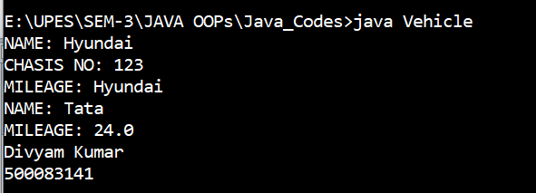

Question 3:

ALGORITHM:

Step 1: START

Step 2: Create class Promo

Step 3: define method add as void data type taking an integer variable and a float variable as arguments

Step 4: Print sum of arguments as statement of method add

Step 5: define method sum as void data type taking 2 double as arguments

Step 6: print sum of arguments as statement of method add

Step 7: define main method

Step 8: create an instance of Promo class inside main function

Step 9: p. add(integer,integer) by calling add method

Step 10: p.add(integer,integer) by calling add method

Step 11: END

CODE:

class Promo

{

void add(float a,int b)

{

System.out.println("Sum :" +(a+b));

}

void add(double a, double b)

{

System.out.println("Sum :"+(a+b));

}

public static void main(String[] args) {

Promo p = new Promo();

p.add(20,20);

p.add(7,3);

System.out.println("Divyam Kumar\n500083141");

}

}

OUTPUT:

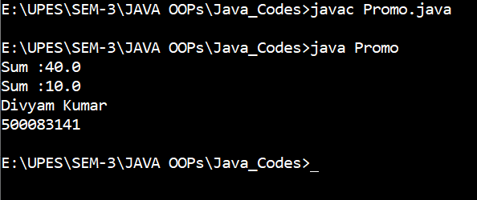

Question 4:

ALGORITHM:

Step 1: START

Step 2: make a class Consover

Step 3: define the field variables

Step 4: make default constructors of the class Consover having different parameter

Step 5: make methods for calculating area and volume.

Step 6: in the main method we make two objects of the class Consover and pass the values for the default constructor.

Step 7: call the methods area and volume and print the output.

Step 8: END

CODE:

class Consover {

int len, bre , hei;

Consover(int a, int b, int c) {

len = a;

bre = b;

hei = c;

}

Consover(int a, int b){

len = a;

bre= b;

}

int area(){

int ar = len * bre;

return ar;

}

int vol(){

int vol = len * bre * hei;

return vol;

}

public static void main(String[] args) {

Consover a1 = new Consover(10, 5 , 60);

Consover a2 = new Consover(5 , 4);

int ar = a2.area();

int vol = a1.vol();

System.out.println("\nDivyam Kumar");

System.out.println("500083141");

System.out.println("Area = " + ar);

System.out.println("Volume = " + vol);

}

}

OUTPUT:

